GULISTAN & TURGUT OZAL EDUCATIONAL INSTITUTIONS
INFORMATICS LESSON PLAN

DATE : DURATION: 40 minutes
GRADE LEVEL : 10th Class
SUBJECT : Output statements (cout)
OBJECTIVES : To learn how to send message to screen

LESSON PLAN
Key words : ASCII, endl, operator, cout, string,
Warm-up questions :

Introduction and explanation of the lesson;
(3 min)The three objects "Hel", "lo, wo", and "rld!" in previous lesson are called string literals. Each literal consists of a sequence of characters delimited by quotation marks.

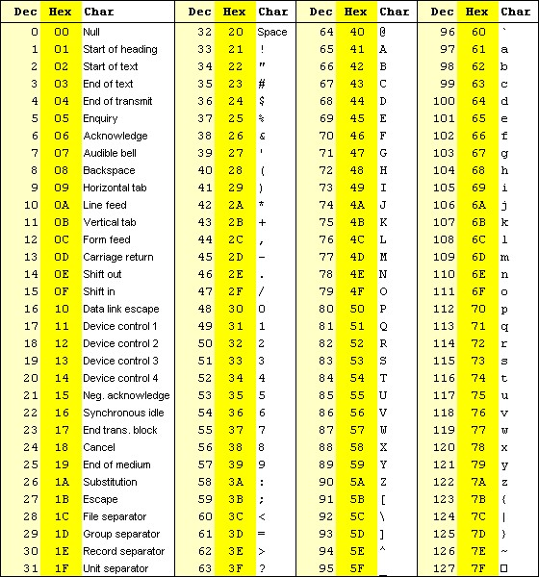
A character is an elementary symbol used collectively to form meaningful writing. English writers use the standard Latin alphabet of 26 lower case letters and 26 upper case letters along with the 10 Arabic numerals and a collection of punctuation marks. Characters are stored in computers as integers. A character set code is a table that lists the integer value for each character in the set. The most common character set code in use at the end of the millennium is the ASCII Code.

(10 min)ASCII Table and Description
ASCII stands for “American Standard Code for Information Interchange”. Computers can only understand numbers (actually ones and zeros, but as a result this ones and zeros stored and treated as numbers), so an ASCII code is the numerical representation of a character such as 'a' or '@' or an action of some sort. ASCII was developed a long time ago and now the non-printing characters are rarely used for their original purpose. Below is the half of the ASCII character table and this includes descriptions of the first 32 non-printing characters. ASCII was actually designed for use with teletypes and so the descriptions are somewhat obscure. If someone says they want your CV however in ASCII format, all this means is they want 'plain' text with no formatting such as tabs, bold or underscoring - the raw format that any computer can understand. This is usually so they can easily import the file into their own applications without issues. Notepad.exe creates ASCII text, or in MS Word you can save a file as 'text only'. We studied a little bit about the ASCII in previous lessons and we learned that:
- Some common chars from ASCII table has the following values:
’a’ ➔ 97, ’b’ ➔ 98, ’c’ ➔ 99, … ’z’ ➔ 122
’A’ ➔ 65, ’B’ ➔ 66, ’C’ ➔ 67, … ’z’ ➔ 90
’0’ ➔ 48, ’1’ ➔ 49, ’2’ ➔ 50, … ’9’ ➔ 57
Enter char ➔ 10 and 13, Esc char ➔ 27, Space char ➔ 32, etc.

(5 min)The newline character '\n' is one of the nonprinting characters. It is a single character formed using the backslash \ and the letter n. There are several other characters formed this way, including the horizontal tab character '\t' and the alert character \a'. The backslash is also used to denote the two printing characters that could not otherwise be used within a string literal: the quote character \" and the backslash character itself \\. As individual objects, character constants can be output the same way string literals are. A character constant is a character enclosed in single quotes: '!', 'a', 'b', etc.

(10 min)Example: A Fourth Version of the "Hello, World" Program
This program has the same output as that Example in previous lesson.
#include <iostream>
using namespace std;
int main()
{ // prints "Hello, World!":
cout << "Hello, W" << 'o' << "rld" << '!' << '\n';
}
This shows that the output operator can process characters as well as string literals. The three individual characters 'o', '!', and '\n' are concatenated into the output the same way as the two string literals "Hello, W" and "rld".

Example: Inserting Numeric Literals into the Standard Output Stream
#include <iostream>
using namespace std;
int main()
{ // prints "The Millennium ends Dec 31 2000.":
cout << "The Millennium ended Dec " << 3 << 1 << ' ' << 2000 << endl;
}
When numeric literals like 3 and 2000 are passed to the output stream they are automatically converted to string literals and concatenated the same way as characters. Note that the blank character (' ') must be passed explicitly to avoid having the digits run together.
(5 min) Then students are asked to write these programs on their computers.

CONCLUSION:

HOMEWORK: To search the entire ASCII table. And new standards for ASCII table.
Teacher Director

